# **IP Address Classification (task 1)**

1 A  
2 B

3 C

4 B

5 C

6 A

7 C

8 D

9 B

10 A

11 E

12 C

13 A

14 C

15 C

16 A

17 A

18 B

19 C

# **Network and Host identification (Task 2)**

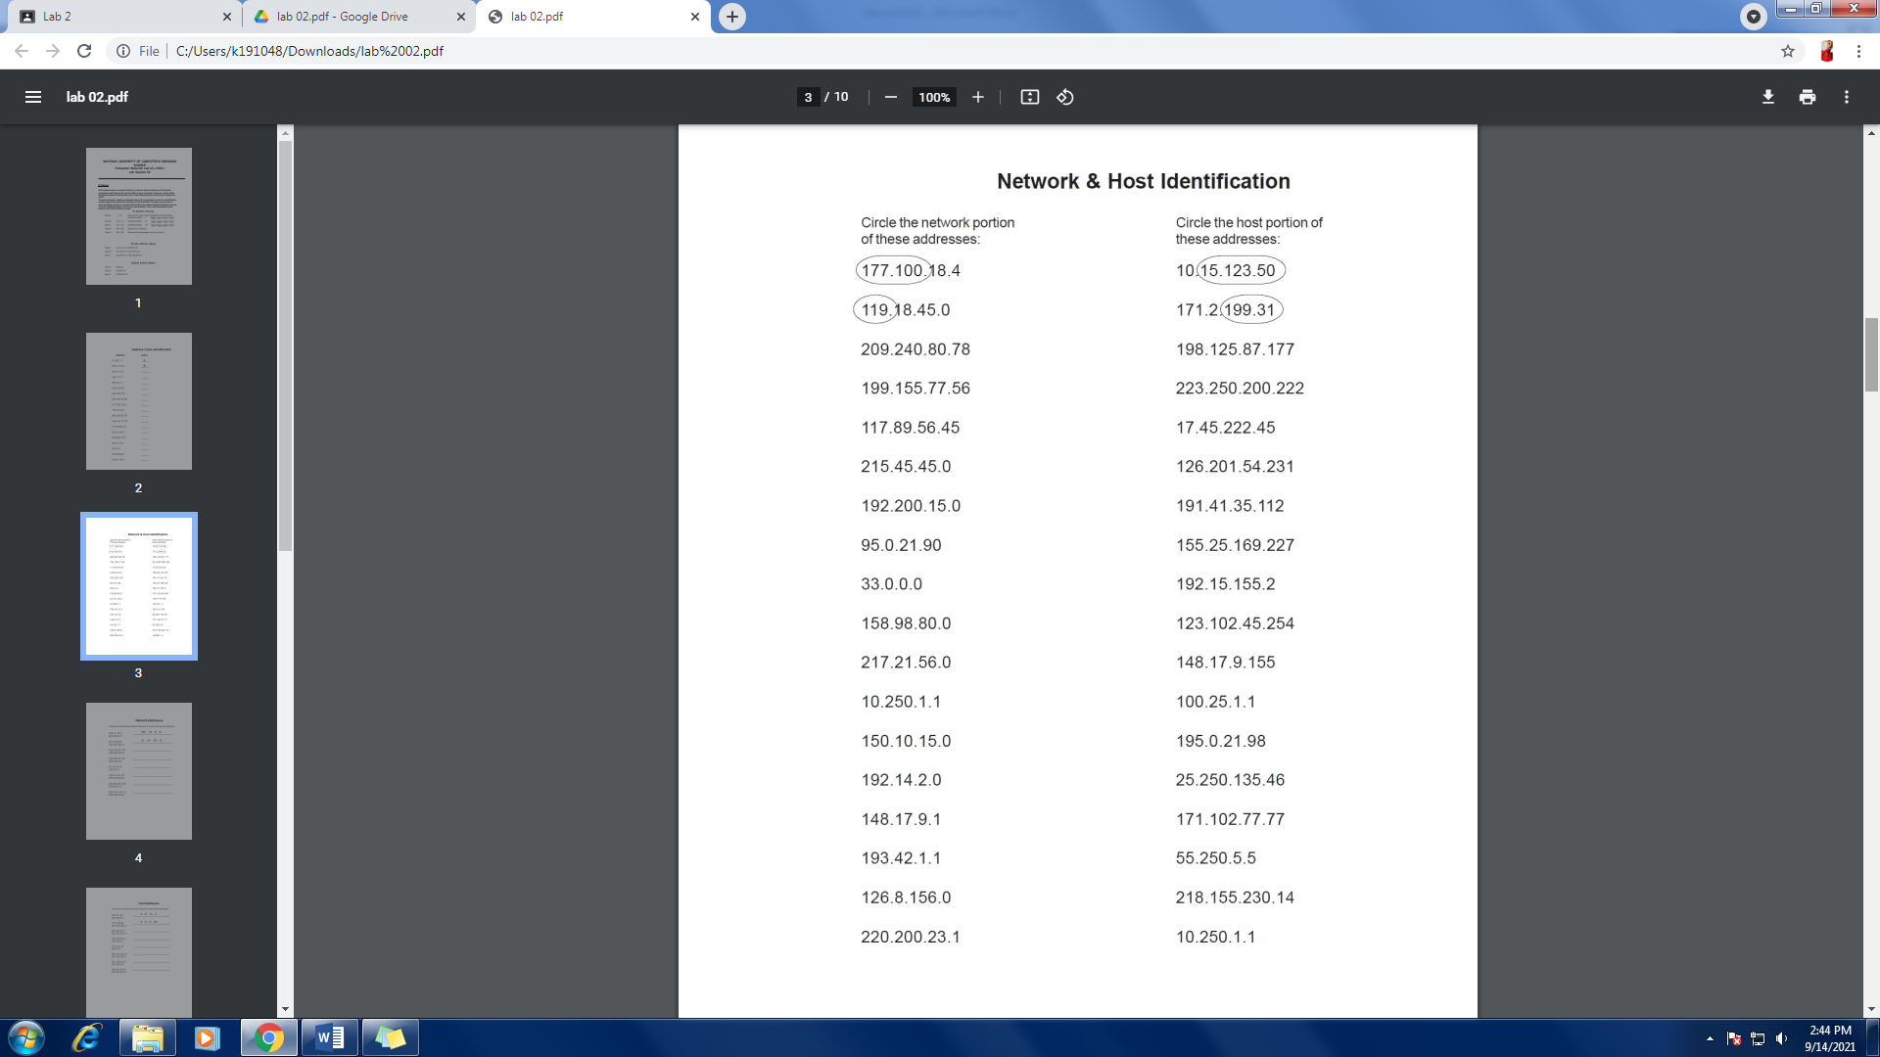

# Network Address

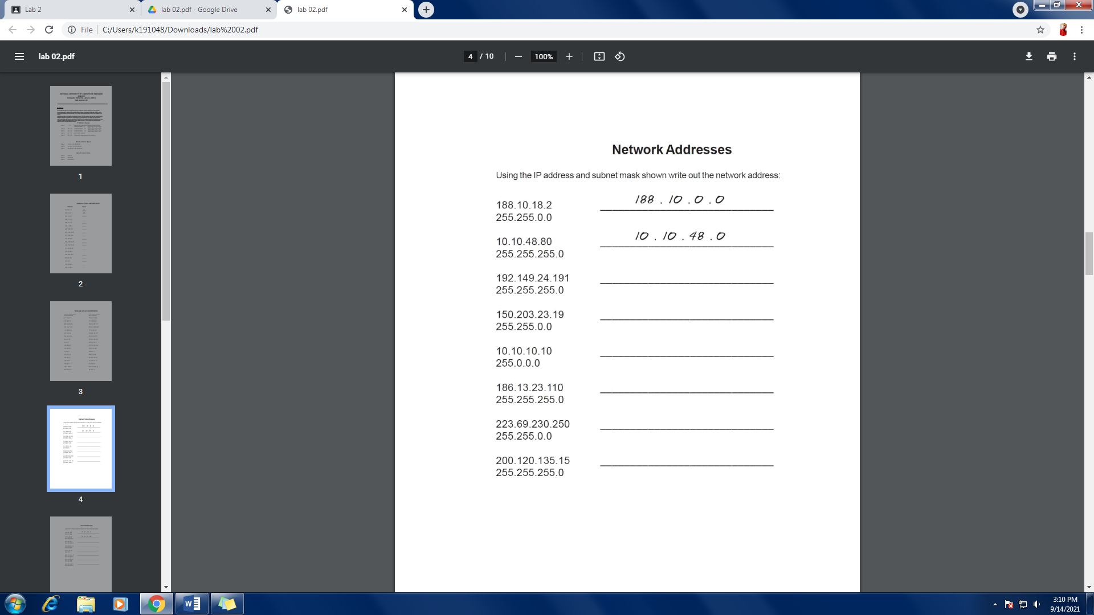

200.120.135.0

223.69.0.0

186.13.23.0

10.0.0.0

150.203.0.0

192.149.24.0

# Host Address

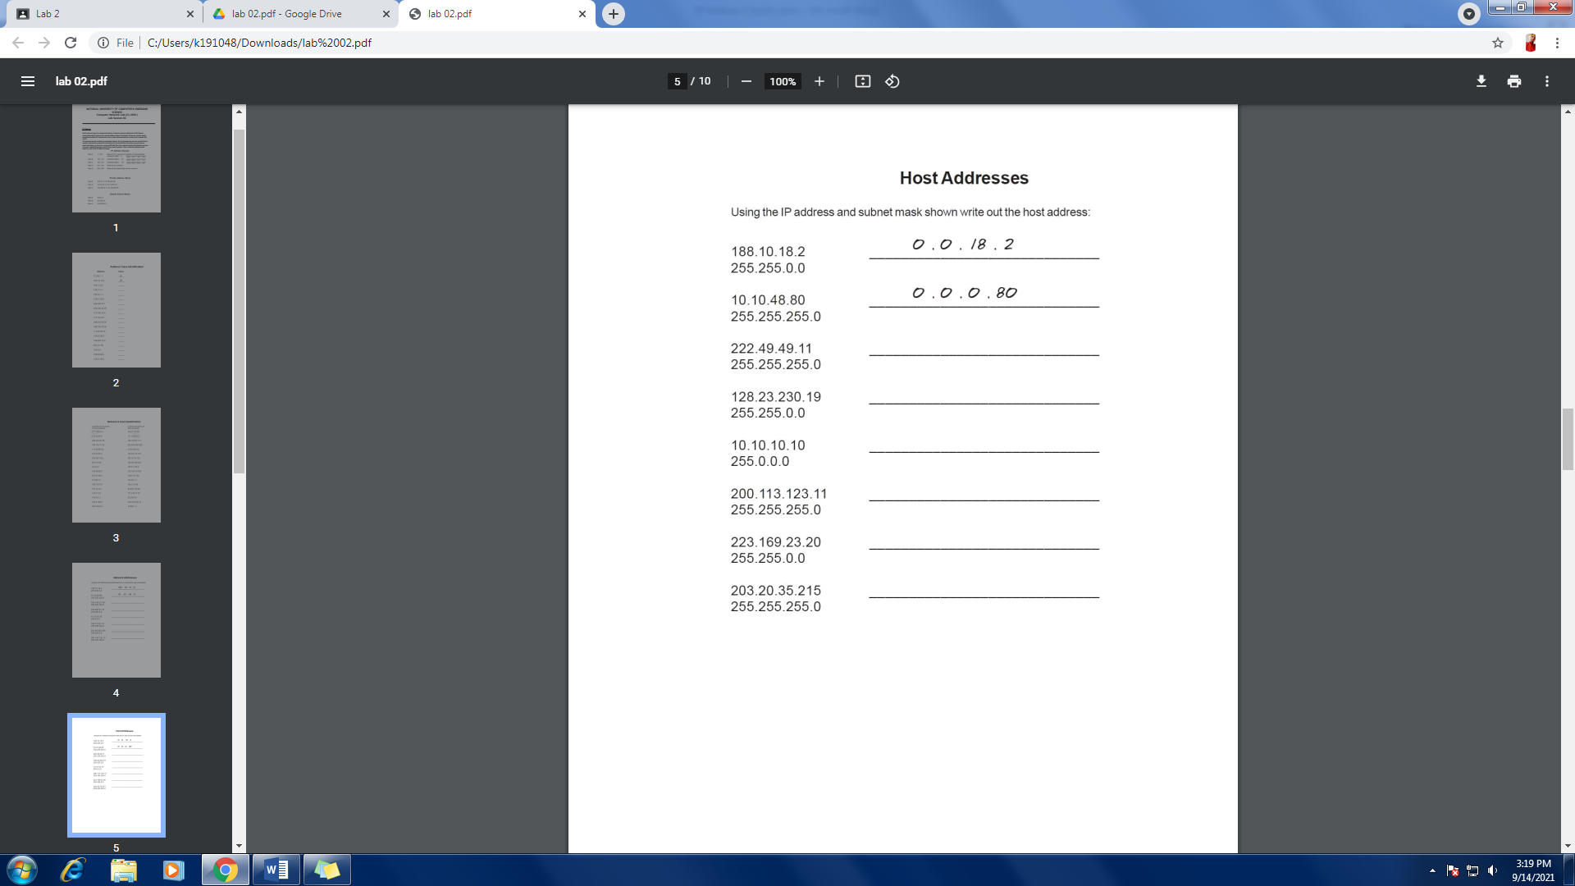

0.0.0.215

0.0.23.20

0.0.0.11  
|4  
1

0.10.10.10

0.0.230.19

0.0.0.80

# Default Subnet Mask

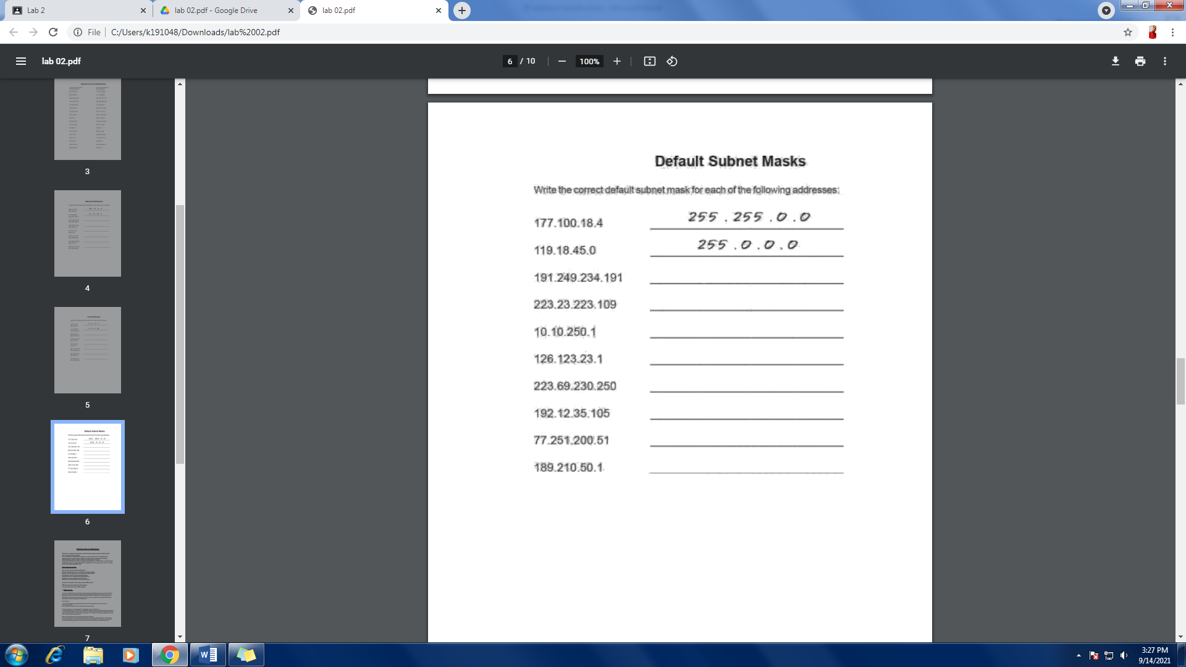

255.255.0.0

255.0.0.0

255.255.255.0

255.255.255.0

255.0.0.0

255.0.0.0

255.255.255.0

255.255.0.0

# WireShark

### **Q.1 What is the IP address of your host? What is the IP address of the destination host?**

Source: 172.16.11.121

Destination: 172.16.11.120

### **Q.2 Why is it that an ICMP packet does not have source and destination port numbers?**

The ICMP packet does not have source and destination port numbers **because it communicates information between hosts and routers.**

### **Q.3 Examine one of the ping request packets sent by your host. What are the ICMP type and code numbers? What other fields does this ICMP packet have? How many bytes are the checksum, sequence number and identifier fields?**

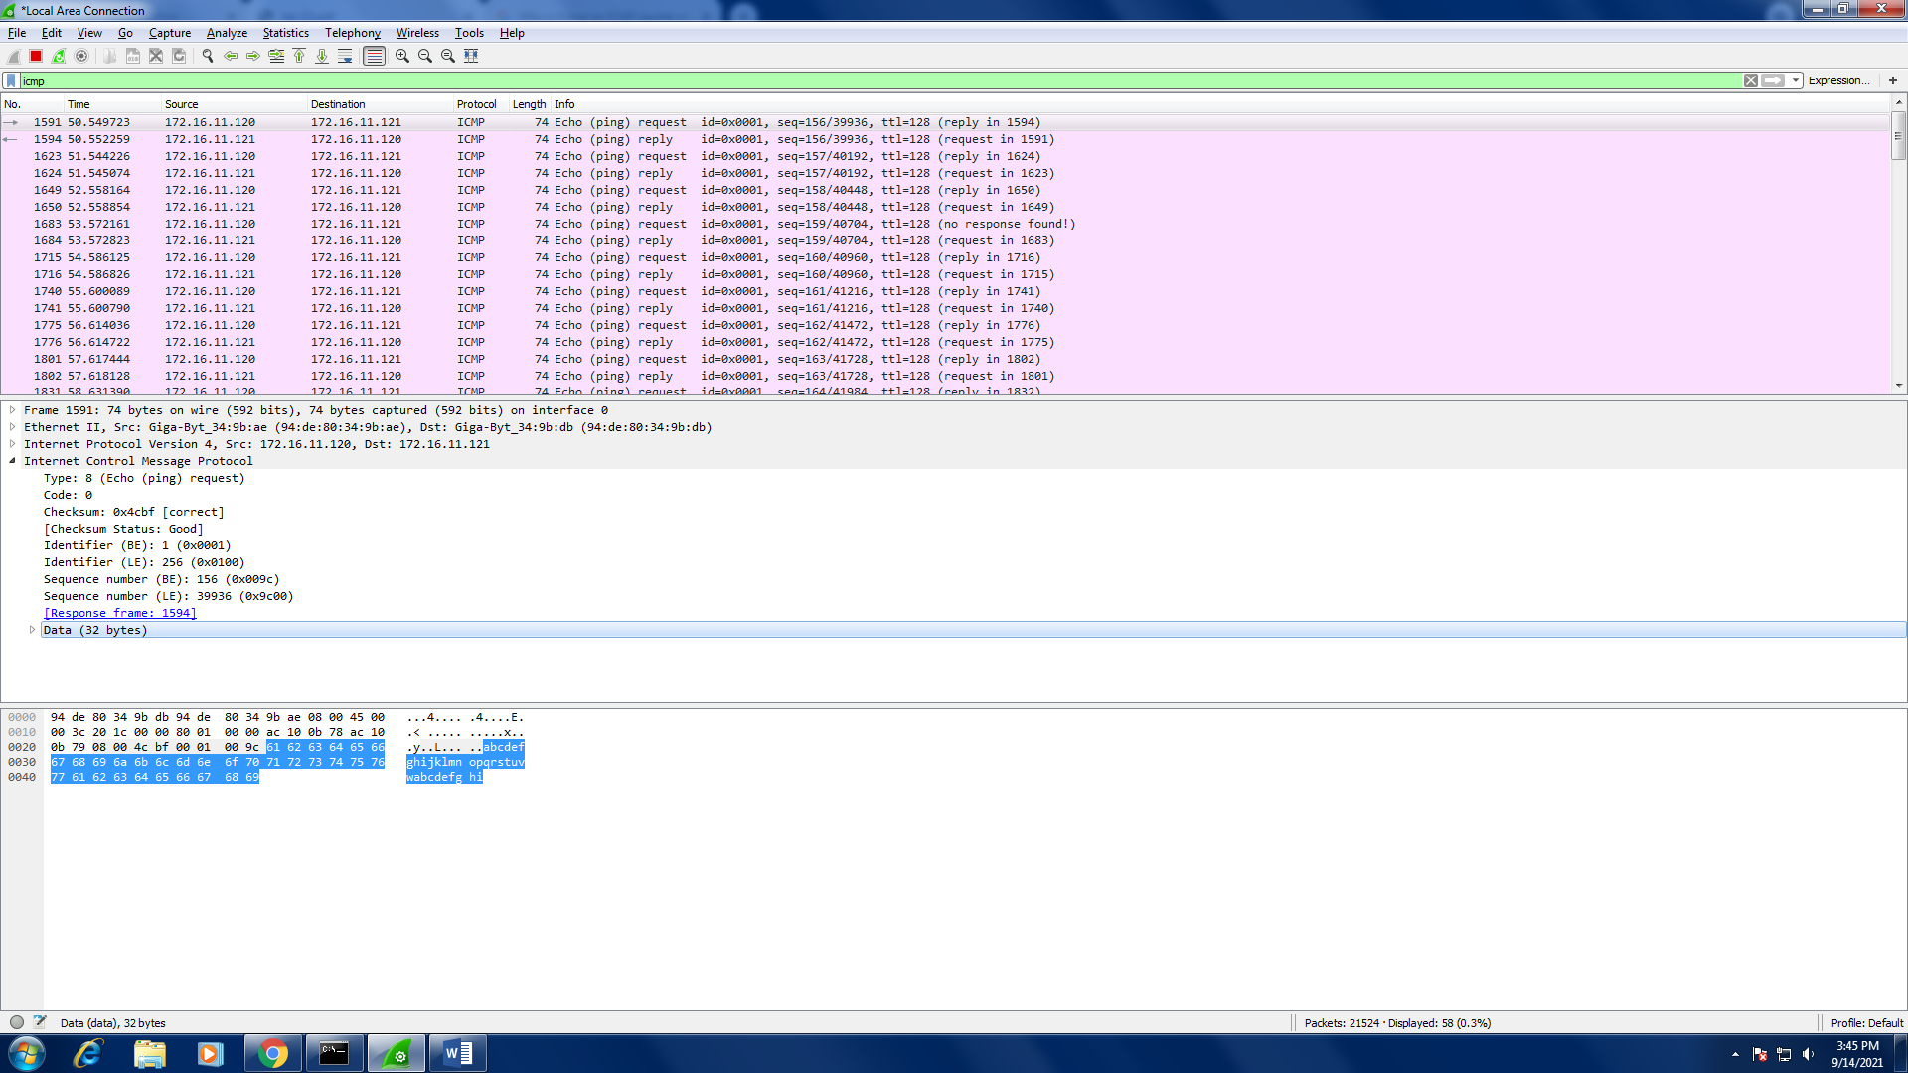

### Q.4 Examine the corresponding ping reply packet. What are the ICMP type and code numbers? What other fields does this ICMP packet have? How many bytes are the checksum, sequence number and identifier fields?

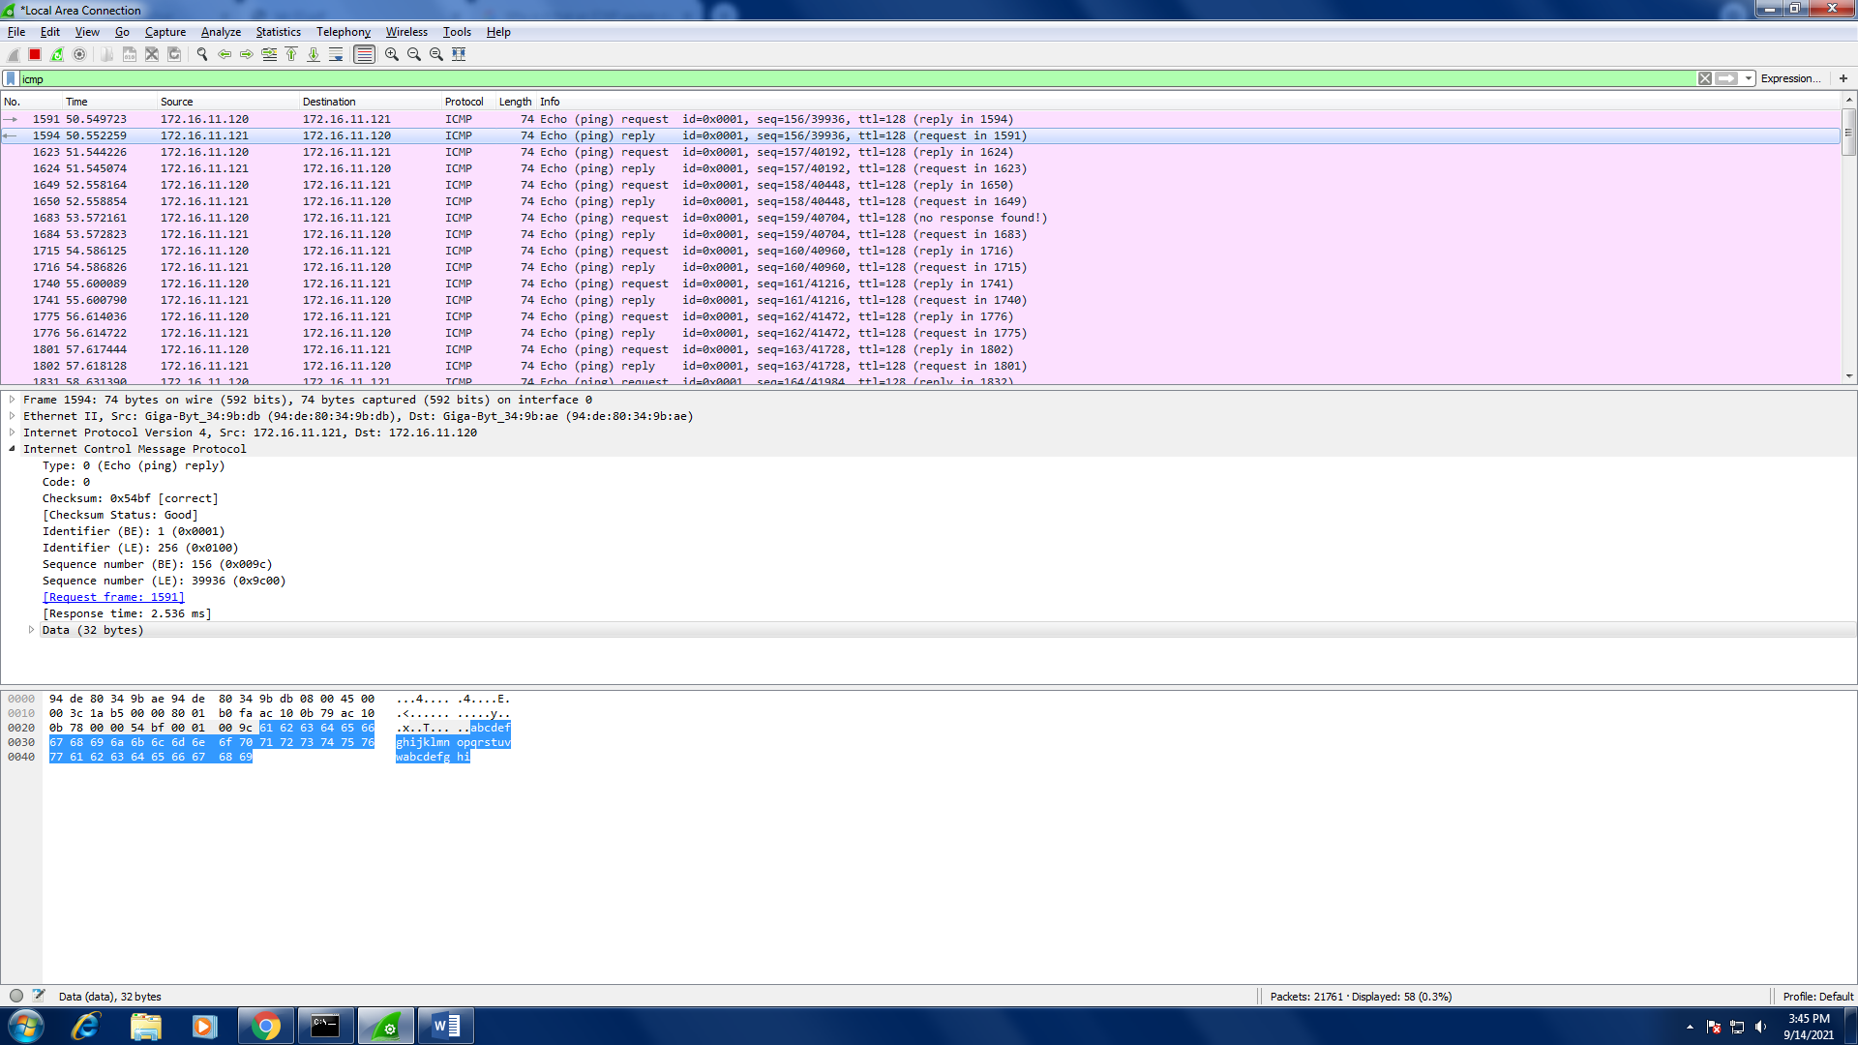

### Q.5 Open your browser and go to www.google.com capture packets on wireshark, attach screenshots in submission.

